A0 AND Gate
Architecture brief — parts, rules, measurements, decisions
One mRNA that produces GFP only when two RNA inputs are present together. A main hairpin sequesters the ribosome binding site and the start codon; an inhibitory hairpin immediately upstream of it sequesters the site where the main trigger would land. Trigger B opens the inhibitory hairpin and exposes that site; trigger A then opens the main hairpin. The variant is named A0 because the spacer between the two hairpins, a, is 0 — so trigger A has no exposed nucleotide anywhere on the switch until trigger B has acted.
1. The construct
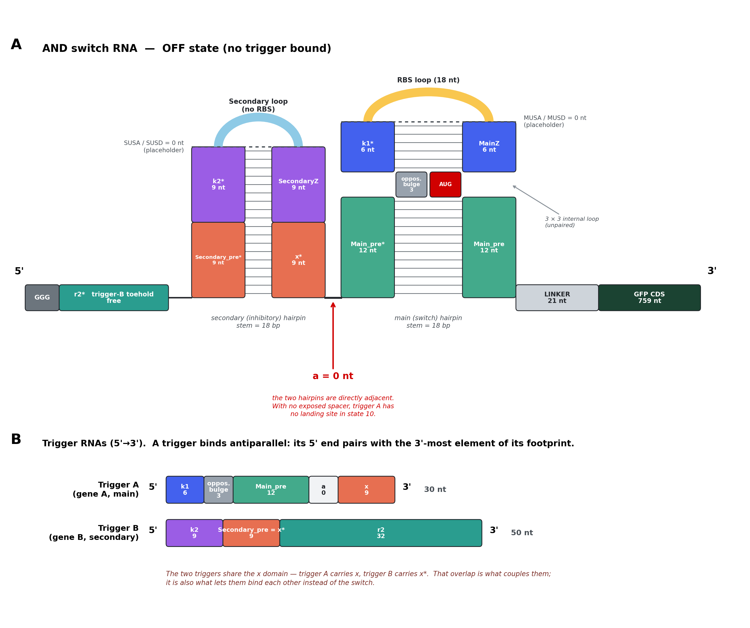
Figure 1. The switch in the OFF state, and the two triggers. Domains that pair share a colour. Lengths are the reference design: both stems 18 bp, main stem split 12 + 6, |x| = 9.
1.1 Every element, 5' → 3'
“Pairs with” describes the OFF state. Only len_x and len_r2 are free; everything else is fixed or derived.
# | element | pairs with | length (nt) | sequence determined by
1 | cap | — free | 3 | fixed: GGG
2 | r2* | — free (trigger-B toehold) | len_r2 = 32 | revcomp(r2); gene B
3 | Secondary_pre* | x* (#9) | len_x | = x; gene A
4 | k2* | SecondaryZ (#8) | 18 − len_x | revcomp(k2); gene B
5 | SUSA | SUSD (#7) | 0 | placeholder
6 | Secondary loop | — free | 15 | fixed; no RBS-like motif, no AUG
7 | SUSD | SUSA (#5) | 0 | placeholder
8 | SecondaryZ | k2* (#4) | 18 − len_x | ≈ k2, weakened by ddG_pref (R6)
9 | x* | Secondary_pre* (#3) | len_x | revcomp(x); gene A
10 | a | — free | 0 | the defining parameter of A0
11 | Main_pre* | Main_pre (#19) | 12 | revcomp(Main_pre); gene A
12 | opposing_bulge | — free in OFF;  paired by trigger A in ON | 3 | revcomp of trigger A's 3 nt (R7)
13 | k1* | MainZ (#17) | 6 | revcomp(k1); gene A
14 | MUSA | MUSD (#16) | 0 | placeholder
15 | RBS loop | — free | 18 | fixed; RBS flush at its 3' end
16 | MUSD | MUSA (#14) | 0 | placeholder
17 | MainZ | k1* (#13) | 6 | ≈ k1, weakened by ddG_pref (R6)
18 | AUG | — free | 3 | fixed: start codon
19 | Main_pre | Main_pre* (#11) | 12 | gene A
20 | LINKER | — free | 21 | fixed
21 | GFP CDS | — free | 759 | fixed

Elements 5, 7, 10, 14 and 16 are zero-length placeholders, kept in the layout so a future version can add an upper stem to either hairpin, or re-open the inter-hairpin spacer, without renumbering anything.
1.2 The two triggers
Trigger A (main, gene A) 5'- k1 - opposing_bulge - Main_pre - a - x -3'
Trigger B (secondary, gene B) 5'- k2 - Secondary_pre - r2 -3'
Reading rule. A trigger binds antiparallel, so its 5' end pairs with the 3'-most element of its footprint on the switch. Listing a trigger's domains in switch order gives the reverse of the correct sequence.
The shared domain. Secondary_pre = x*, so trigger A carries x and trigger B carries x*. That overlap is what couples the two halves of the gate — and it is also what lets the two triggers bind each other instead of the switch (R10).
1.3 The four states
state | inputs | what happens | output
00 | neither | both hairpins closed; x* is paired | OFF
10 | trigger A only | x* still paired — A has nothing to nucleate on | OFF
01 | trigger B only | secondary hairpin opens and frees x*; the AUG stays locked | OFF
11 | A + B | A nucleates on the freed x*, then branch-migrates through Main_pre* and k1*, displacing MainZ and Main_pre and freeing the start codon | ON

2. Design rules
 | rule | why
R1 | Both hairpin stems are 18 bp. len_main_pre + len_k1 = 18 and len_x + len_k2 = 18. | Published stems measure 15 (Green), 17 and 19 (Kim). 18 sits inside that band and closes every other length in the design.
R2 | len_k1 = 6, so len_main_pre = 12. | The RBS sits flush against the 3' end of its loop, so len_k1 is the Shine–Dalgarno-to-start-codon spacing. That spacing is 6 nt in Green, in Kim, and in all five of our own tested switches.
R3 | a = 0. The two hairpins are directly adjacent. | The defining parameter. Kim's series shows the gate becomes more AND-like as a shrinks; A0 takes it to the limit, so the dependency is structural rather than a matter of degree.
R4 | Everything between the start codon and the GFP CDS must sum to a multiple of 3. Today that is Main_pre (12) + LINKER (21). | Reading frame. Stated in the general form so it still holds if an element is inserted there later.
R5 | No in-frame stop codon in Main_pre. A hard filter inside the search, not a check afterwards. | Main_pre is a literal stretch of gene A translated as an N-terminal extension of GFP. Costs 8–13 % of candidate windows on our real transcripts.
R6 | MainZ and SecondaryZ bind strictly weaker than the trigger, by a configurable margin ddG_pref — one wobble, one mismatch or a 1-nt bulge. | Each Z is a copy of the trigger's own domain. A perfect Watson–Crick copy would bind harder than the real trigger, which carries wobbles — the trigger would be climbing uphill to displace the clamp meant to release it.
R7 | A 3-nt opposing_bulge faces the AUG across the main stem, forming a 3 × 3 internal loop. | In ON, trigger A pairs straight through it: 21 contiguous base pairs where the hairpin managed 18 plus an internal loop. Worth 9.8 kcal/mol of drive against 1.9 without it. It also breaks the stem into two shorter helices, reducing RNase III exposure.
R8 | The RBS loop is 18 nt: a designed 7-nt flank followed by the fixed 11-nt RBS, which stays flush at the loop's 3' end. | Both reference designs are built the same way and differ only in flank length (Green 0 nt, Kim 4 nt). The 3'-flush RBS is what makes R2 true.
R9 | The secondary loop carries no SD-like motif and no start codon. | It must not create a second ribosome entry point. Kim's 15-nt inhibitory loop satisfies this and is our starting sequence.
R10 | Overlap: |x| = 4 to 14, and every value is designed and scored — not only the longest available. Mismatches are allowed at every length; once |x| ≥ 8 the longest uninterrupted complementary run between the two triggers must be ≤ 4 nt. | |x| is trigger A's only nucleation site, so longer is better — and it is also where the two triggers are complementary to each other, so longer is worse. The run cap is a screen; the acceptance test is the measured duplex energy (§3.4).
R11 | Trigger lengths follow: A = 21 + len_x, B = 18 + len_r2. | A is 30 nt at |x| = 9, the length both reference designs used. B is 50 nt at len_r2 = 32.
R12 | Any pattern-prevention list given to a sequence designer is scoped to designed positions only. | The standard list forbids rrrrrr — six purines — and the RBS ends in AGGAGA. Applied to the whole strand it would reject the ribosome binding site itself.

3. How designs are measured
3.1 The four states
Each state is evaluated as a multi-strand equilibrium. Per state we record the ensemble free energy, the MFE structure and its probability, the centroid structure with its distance from the MFE, the base-pairing probability matrix, and the accessibility series of §3.2.
3.2 Accessibility around the start codon
The reported quantity is the probability that a defined window is entirely unpaired at once, not the average over its bases:
P_open(W) = Z( all of W unpaired ) / Z dG_open(W) = - RT · ln P_open(W)
A ribosome does not sample bases independently — it needs its whole footprint free at the same moment. For a window whose bases are each 90 % unpaired, the averaged metric always reads 0.90 while the joint probability lies anywhere between 0.90 and far less. Only the joint probability matches the physical requirement. ViennaRNA computes it directly: one hard-constrained partition function per window.
Windows, all anchored on the start codon and reported as a nested series: the AUG alone; the RBS through the AUG; AUG through AUG + 3n for n = 1…10 codons; and the 30-nt ribosome footprint. Reporting the whole series rather than one window shows how far the opening extends — which is what separates a switch that merely exposes the AUG from one that clears the ribosome's path.
3.3 Discrimination
ddG_AND = [ dG_open(11) - dG_open(01) ] - [ dG_open(10) - dG_open(00) ]
How much more trigger A opens the switch when trigger B is present than when it is absent. Length cancels in the difference, so this needs no normalisation. Separation is reported threshold-free: state 11 against the worst of 00, 01, 10.
3.4 Trigger–trigger sequestration
Reported at a stated concentration (10 nM per transcript) as the duplex free energy, the resulting bound fraction, and the longest complementary run. This is a ranking input, not a veto: Kim's own published trigger pair, in the construct they describe as a working two-input AND gate, sits at 73 % sequestration by this calculation.
3.5 Which structure the ranking reads
P(MFE) collapses with length. On our own switches it is 0.02–0.08 for the switch alone and about 3 × 10⁻¹⁵ for the full construct with GFP — and at that length the MFE and the centroid disagree about whether the start codon is paired in 2 of 5 constructs. The ranking therefore reads the centroid and the pairing probability matrix; the MFE is reported but trusted only over the isolated hairpin region. Disagreements are flagged, not silently ranked. (Decision D11.)
3.6 Assertions that halt the run
 | assertion
1 | Every declared helix pairs antiparallel with zero mismatches, wobbles only where declared. This is what catches domain-order errors.
2 | The intended OFF dot-bracket, written from the element spans of §1.1 and independent of any folding, is diffed against both the MFE and the centroid.
3 | (len_main_pre + len_LINKER) mod 3 = 0, and no in-frame stop from the AUG through the end of the GFP CDS.
4 | The RBS appears exactly once, is flush at the loop's 3' end, and the SD→AUG spacing equals len_k1 and is reported.
5 | No AUG between the RBS loop and the intended start codon that could initiate out of frame.
6 | MainZ binds k1* strictly weaker than trigger A's k1 does, by at least ddG_pref. Same for SecondaryZ against k2.
7 | len_x ≥ 4; len_x + len_k2 = 18; len_main_pre + len_k1 = 18; and for len_x ≥ 8 the longest complementary run between the triggers is ≤ 4 nt.
8 | Trigger A's x and trigger B's Secondary_pre are reverse complements over the matched positions.
9 | The cap sits at the 5' end of the finished construct, not stranded internally.
10 | Any design carried between stages is matched on its full identity — len_x, len_main_pre, len_k1, len_k2, ddG_pref, mismatch pattern — never a partial key.
4. Decisions we need
Six carry a recommendation we are ready to act on unless you disagree. The six shaded rows are genuine choices where we do not think the evidence settles it.
# | decision | our position
D1 | Stem length, both hairpins | 18 bp. Inside the published band of 15 / 17 / 19, and it closes every other length.
D2 | Split of the main stem | 12 + 6. Thermodynamically inert either way, but only 12 + 6 gives the 6-nt SD→AUG spacing every reference design uses. Costs about 3 % of the search space to in-frame stops.
D3 | Trigger B total length | Open. 50 nt as instructed gives a 32-nt toehold where Kim used 13. Longer buys specificity but makes B bind far harder than A, which may unbalance the gate. 30–35 nt is the precedent.
D4 | GFP's own leading ATG | Open, we lean to deleting it. Green and Kim keep it; our own switch generator deletes it. Measured: no thermodynamic difference and no second start site either way. A preference, not a result.
D5 | Overlap range and mismatch rule | |x| = 4–14, mismatches at every length, longest run ≤ 4 nt once |x| ≥ 8. Below |x| = 8 mismatches buy nothing thermodynamically, but they are what lets the gene-pair search find anything at all.
D6 | Size and composition of the lab panel | Open. 12 constructs proposed: 8 gate designs (4 levels of |x| × 2 of ddG_pref), 1 benchmark at a = 4, 3 controls.
D7 | Inhibitory loop — fixed or designed? | Open. Start from Kim's fixed 15-nt loop and design de novo where it fails the fold check. Loops are not portable: substituting one into our five tested switches refolded all five.
D8 | Include an a = 4 benchmark construct | Yes. a = 0 is one step beyond Kim's shortest tested spacing; one a = 4 construct puts a known-working point in the panel.
D9 | Accessibility metric | Joint whole-window unpaired probability (§3.2). The averaged per-base metric does not correspond to what a ribosome requires.
D10 | Input gene pairs for the reference study | Open — awaiting your list. Not every pair admits a design: the two windows must be complementary over ≥ 4 nt. This blocks the search.
D11 | MFE or centroid when they disagree? | Open, we lean to the centroid plus the pairing-probability matrix (§3.5). The counter-argument is comparability: published tables report the MFE.
D12 | RBS loop sequence | Keep the 18-nt loop AGACAAGAACAGAGGAGA. It holds the intended fold in all five tested switches. Noted for the record: Green's shorter 11-nt loop measures marginally better on RBS accessibility, 0.77 to 0.68.

Appendix. Fixed sequences
name | sequence | notes
cap | GGG | 3 nt; transcription start, 5' end of the construct
RBS | AACAGAGGAGA | 11 nt, fixed. Identical in Green, in Kim and in our own generator.
RBS loop | AGACAAGAACAGAGGAGA | 18 nt = designed flank AGACAAG + the fixed RBS, which stays flush at the 3' end. See D12.
Secondary loop | CAAGAACUUAGACAA | 15 nt; the inhibitory-hairpin loop of Kim's Sw-G5-G3n* series. Verified to carry no SD-like motif and no start codon. See D7.
LINKER | AACCUGGCGGCAGCGCAAAAG | 21 nt = N L A A A Q K. No in-frame stop, and no SD-like motif, so it creates no second start site.
GFP CDS | ATGCGTAAAGGAGAAGAACTT… (759 nt) | 253 codons, divisible by 3; the only in-frame stops are the terminal TAA TAA. Begins with its own ATG — see D4.
prevent list | aaaa, cccc, gggg, uuuu, kkkkkk, mmmmmm, rrrrrr, ssssss, wwwwww, yyyyyy | Kim's pattern-prevention list, identical to the one in our own generator. Applies to designed positions only (R12).

Sources: Kim et al. 2019, Modulating responses of toehold switches by an inhibitory hairpin — the two-hairpin architecture and the a trade-off. Robson & Green 2026, Toehold-VISTA (NAR) — the switch scaffold, the 21-nt linker and the in-frame-stop filter. All geometry and every energy quoted here was measured with ViennaRNA 2.7.2 at 37 °C, default model; see the full specification for method detail.

